AME : B Tharun kumar reddy

REG NO :192111508

Course : software engineering

Code : CSA1001

Faculty name :DR G Mary valantina

Date :28/09/2022

LIBRARY MANAGEMENT SYSTEM

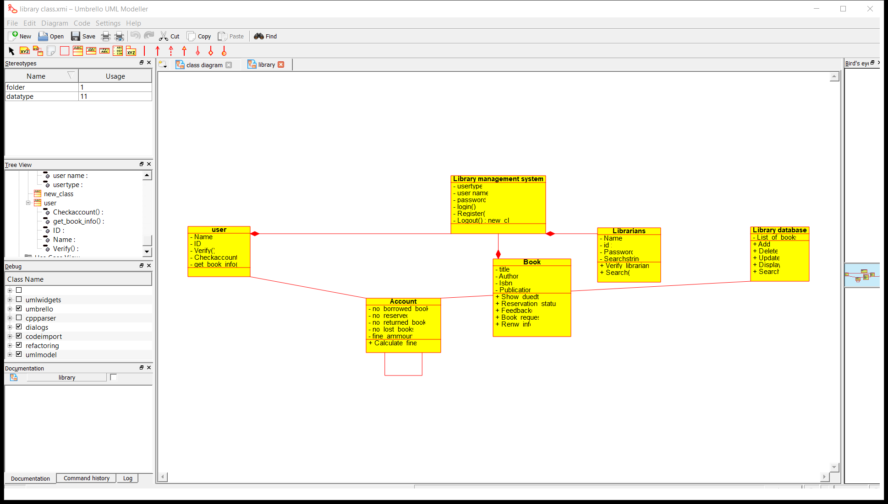

RESULT: I had successfully completed experiment in umbrello software

ONLINE SHOPPING SYSTEM

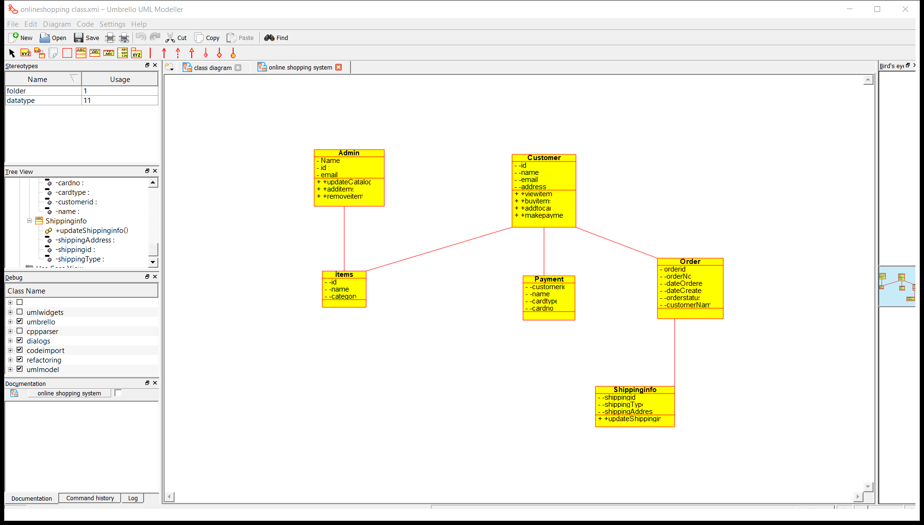

RESULT: I had successfully completed experiment in umbrello software

RAILWAY RESERVATION STSTEM

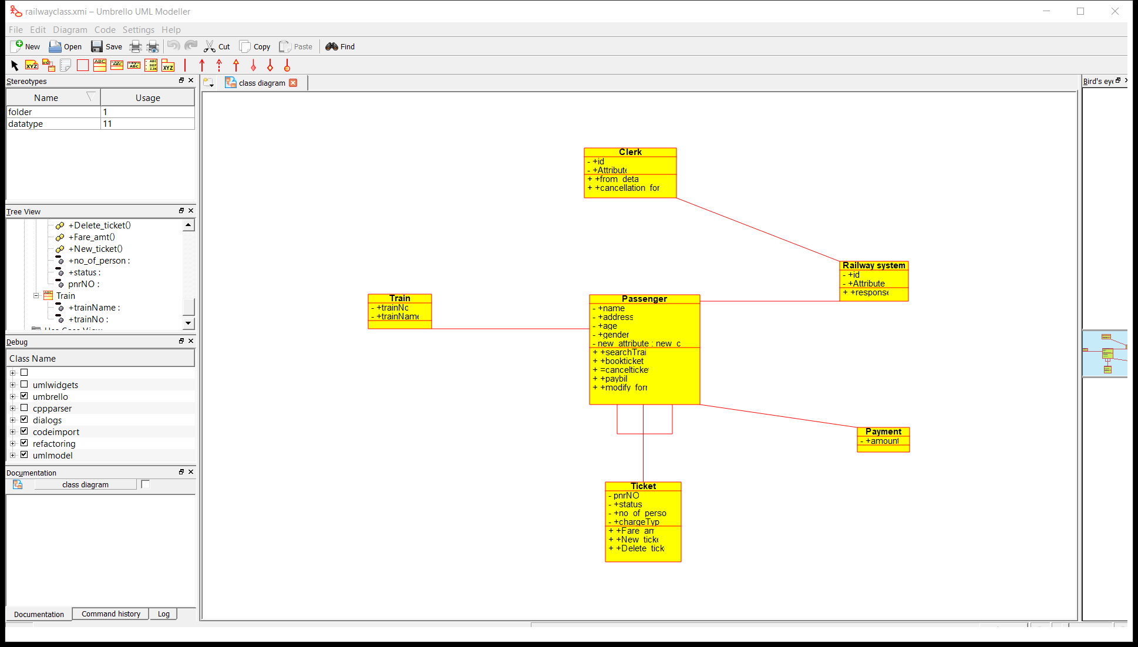

RESULT: I had successfully completed experiment in umbrello software

RAILWAY RESERVATION ACTIVITY DIAGRAM

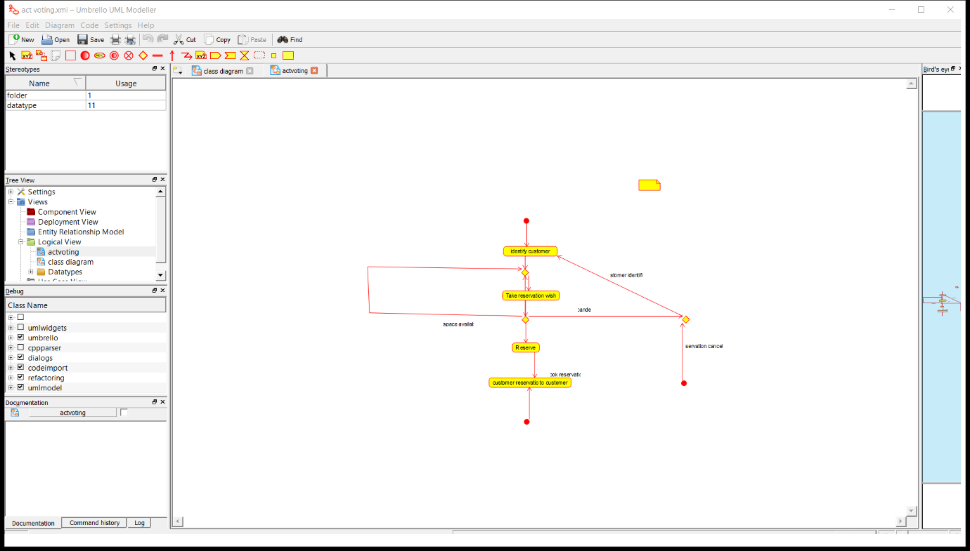

RESULT: I had successfully completed experiment in umbrello software

ONLINE VOTING

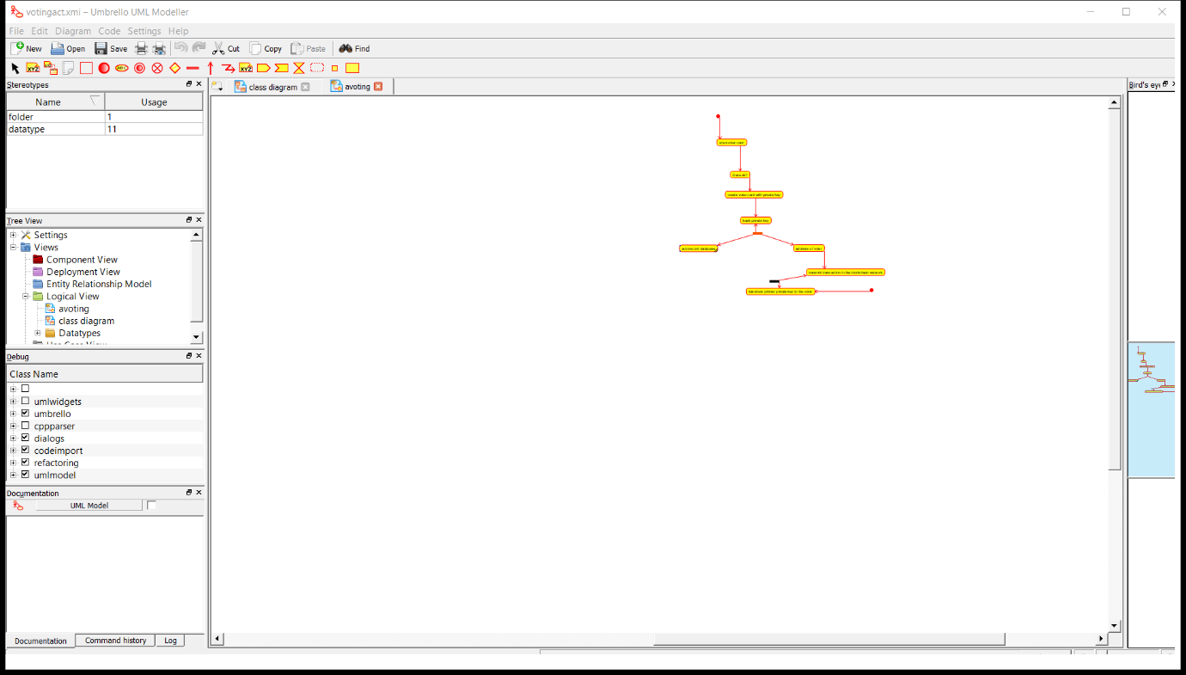

RESULT: I had successfully completed experiment in umbrello software

LIBRARY MANAGEMENT

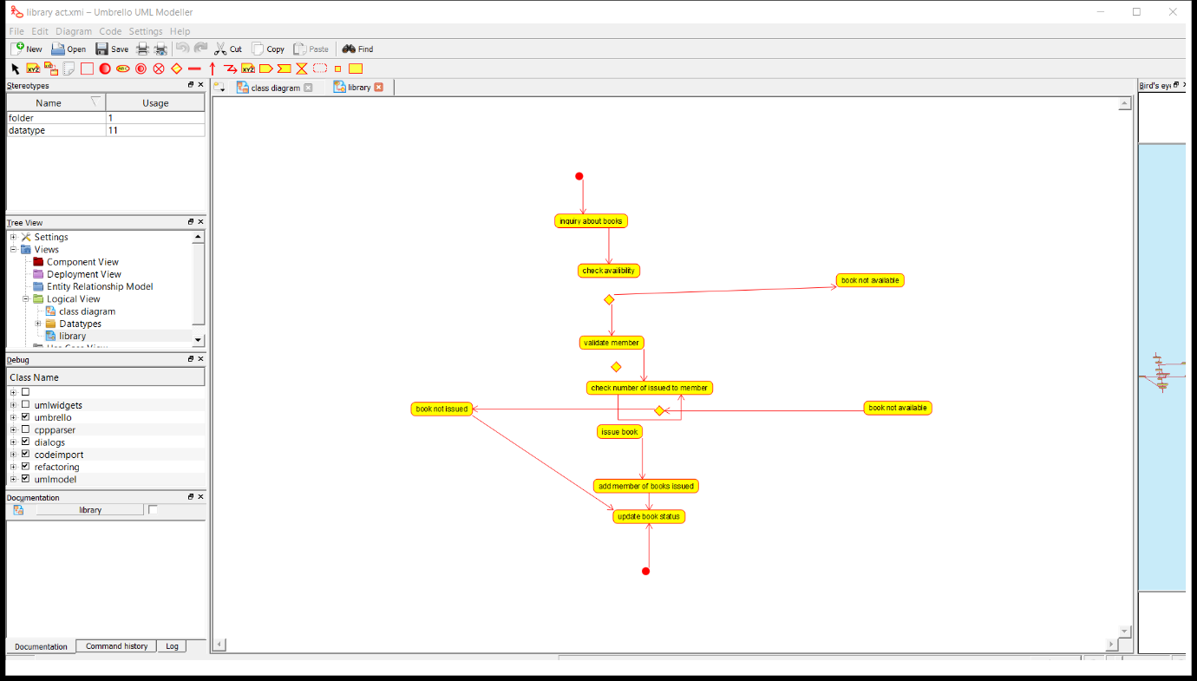

RESULT: I had successfully completed experiment in umbrello software

ONLINE SHOPPING

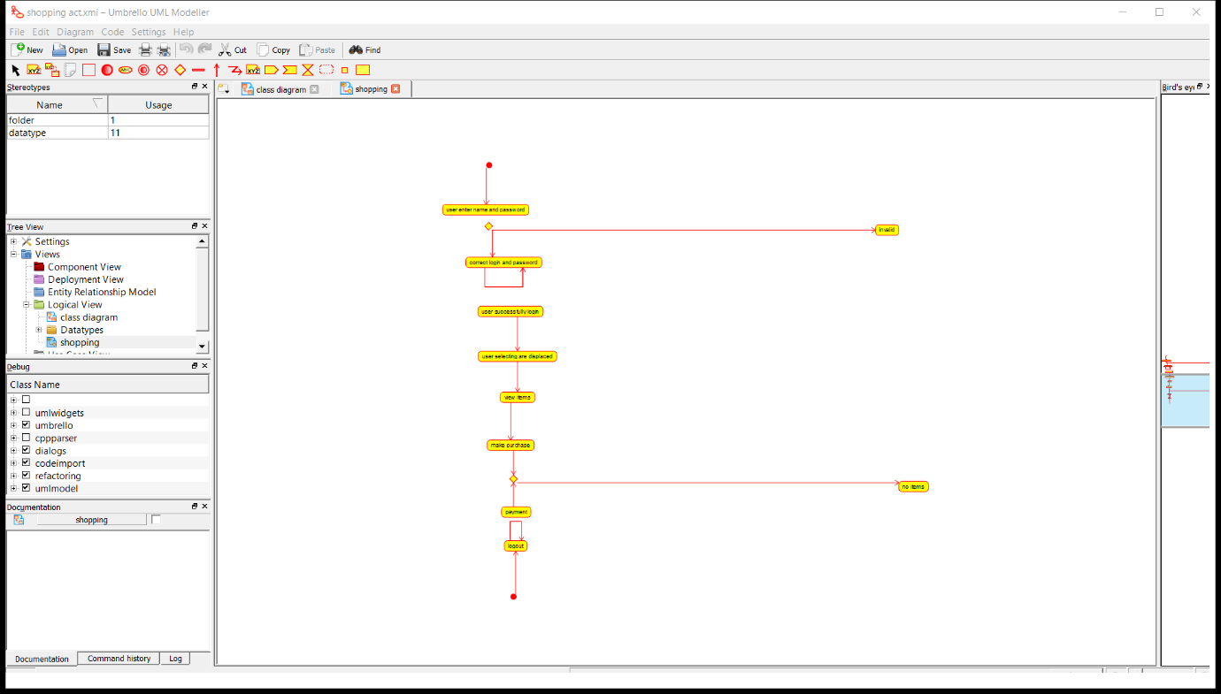

RESULT: I had successfully completed experiment in umbrello software